CODE:-
import cv2
import numpy as np
from matplotlib import pyplot as plt import os

# Step 1: File paths
# Use your actual path
source_path = "/content/image22 (1).jpeg"
reference_path = "/content/image22 (1).jpeg" # for demo, using same file as reference

# Step 2: Load images in grayscale
source_image = cv2.imread(source_path, cv2.IMREAD_GRAYSCALE) reference_image = cv2.imread(reference_path, cv2.IMREAD_GRAYSCALE)

# Check loading
if source_image is None:
raise ValueError(f" Could not load source image. Path = {source_path}") if reference_image is None:
raise ValueError(f" Could not load reference image. Path = {reference_path}")

# Step 3: Histogram Equalization
equalized_image = cv2.equalizeHist(source_image)

plt.figure(figsize=(12, 6))
plt.subplot(2, 2, 1) plt.title('Original Image')

plt.imshow(source_image, cmap='gray') plt.axis('off')

plt.subplot(2, 2, 2) plt.title('Equalized Image')
plt.imshow(equalized_image, cmap='gray') plt.axis('off')

plt.subplot(2, 2, 3) plt.title('Histogram - Original')
plt.plot(cv2.calcHist([source_image], [0], None, [256], [0, 256])) plt.grid(True)

plt.subplot(2, 2, 4) plt.title('Histogram - Equalized')
plt.plot(cv2.calcHist([equalized_image], [0], None, [256], [0, 256])) plt.grid(True)

plt.tight_layout() plt.show()

# Step 4: Histogram Matching
# Compute histograms (normalized)
src_hist = cv2.calcHist([source_image], [0], None, [256], [0, 256])
ref_hist = cv2.calcHist([reference_image], [0], None, [256], [0, 256]) src_hist /= src_hist.sum()
ref_hist /= ref_hist.sum()

# Compute cumulative distribution functions (CDFs) src_cdf = src_hist.cumsum()
ref_cdf = ref_hist.cumsum()

# Mapping from source to reference
mapping = np.interp(src_cdf, ref_cdf, np.arange(256)) matched_image = mapping[source_image].astype(np.uint8)

# Step 5: Show Results plt.figure(figsize=(12, 6))

plt.subplot(1, 3, 1) plt.title('Source Image')
plt.imshow(source_image, cmap='gray') plt.axis('off')

plt.subplot(1, 3, 2) plt.title('Reference Image')
plt.imshow(reference_image, cmap='gray') plt.axis('off')

plt.subplot(1, 3, 3) plt.title('Matched Image')
plt.imshow(matched_image, cmap='gray') plt.axis('off')

plt.tight_layout() plt.show()

#
# Step 6: Observations #
print("\n Observations:")
print("1. The original image histogram may be narrow (low contrast).")
print("2. Histogram Equalization spreads intensity values across 0-255, improving contrast.") print("3. Histogram Matching adjusts the source so its intensity distribution matches the
reference.")
print("4. Equalization always enhances contrast, while Matching adapts source to look like reference.")

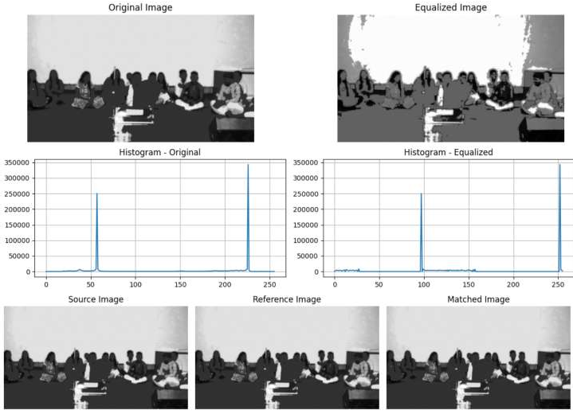
OUTPUT:-

OBSERVATION:-
- Histogram equalization spreads the pixel intensities across the entire 0–255 range, which improves the overall contrast of the image. It enhances the details that were hidden in darker or brighter regions.
- This technique makes dark areas appear darker and bright areas appear brighter, thereby improving visibility. It is particularly useful when the original image has low contrast due to poor lighting.
- However, equalization may sometimes produce results that look unnatural. Since it enhances all intensity levels globally, it can also exaggerate noise or distort smooth regions.
- Histogram matching modifies the source image so that its brightness and contrast distribution resemble that of a chosen reference image. This ensures the output has a style closer to the reference’s lighting conditions.
- Matching is more controlled and produces natural results compared to equalization. It is especially useful when multiple images need to look consistent or when you want one image to visually align with another.

CONCUSTION:-
We learn in this experiment that histogram equalization improves image visibility by stretching contrast, but sometimes looks artificial. Histogram matching, on the other hand, adapts brightness and contrast to a reference image, giving more natural and style-consistent results.

